2020 DISTRICT FUNDRAISER
IRONMAN CHALLENGE
2 HEAD AVERAGE
Men’s Events
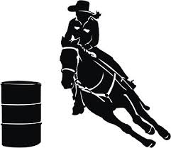
Tie Down Roping Steer Wrestling Heading Heeling
Women’s Events
Barrel Racing
Pole Bending
Goat Tying
Breakaway Roping

During District Finals Weekend - May 21st – 23rd
$200 entry fee
Limited to 20 men and 20 women – first come first serve
District 8 Alumni Only

1st Place - $500 plus buckle
If you don’t want to participate in an event, but still want to compete, you have the option to just take a no time which adds 60 seconds to your overall time.
2nd Place - $300
3rd Place - $200
Awarded in each men and women divisions

Enter with Lynette Smith 208-847-5486 – entries are open now

